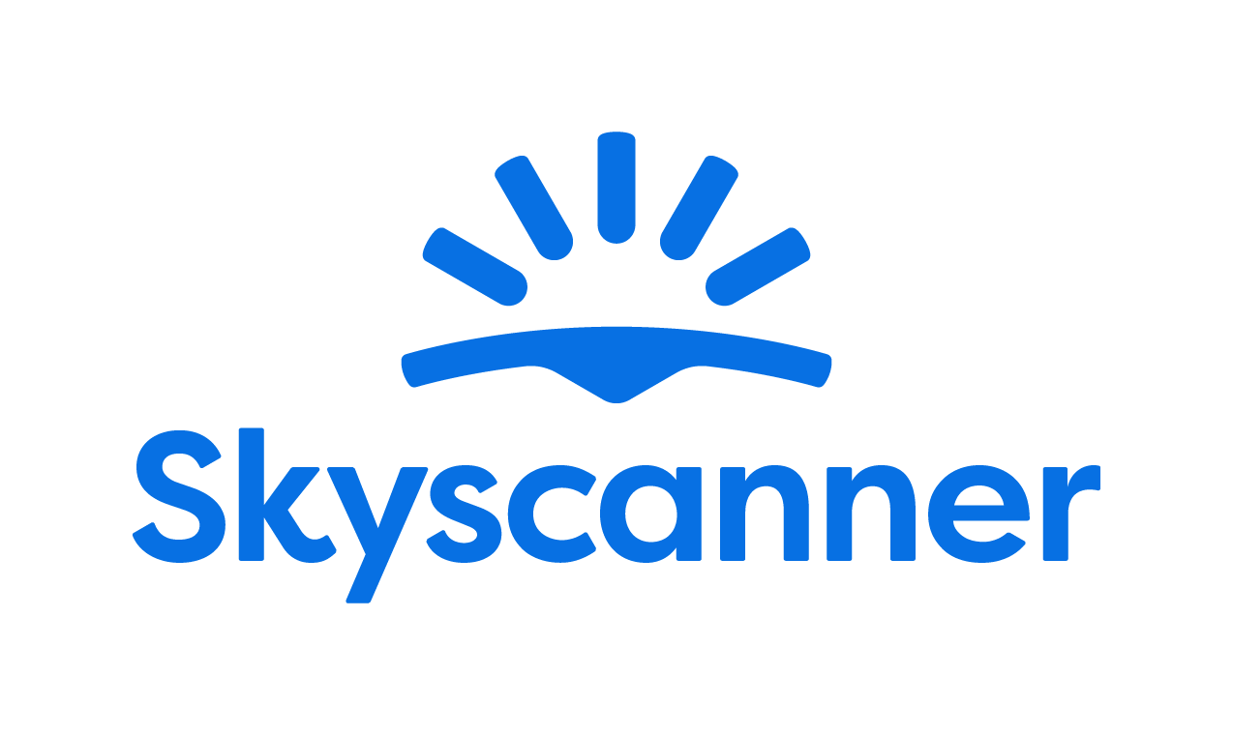

Localization Style Guide

How to write and translate for Skyscanner in US English

1. Our tone of voice 3
1.1 Playful 3
1.2 Geeky 4
1.3 Helpful 5
1.4 Using the tone of voice in localization 7
2. General writing and translation guidelines 8
2.1 URL requirements 8
2.2 Placeholders, variables, and tags 9
2.3 Inclusive language 9
3. Language-specific translation guidelines 10
3.1. Punctuation and spacing 10
3.1.1. Commas 10
3.1.2. Ellipsis 10
3.1.3. Quotation marks 10
3.1.4. Hyphens 11
3.1.5. Dashes 11
3.1.6. Slashes 12
3.1.7. Spaces 12
3.2. Emphasis and intensifiers 13
3.3. References 13
3.4. Capitalization 13
3.4.1. Titles and CTAs 13
3.4.2. Months and days 13
3.4.3. Capital letter after colon 14
3.4.4. Glossary terms / product names 14
3.5. Abbreviations and acronyms 14
3.6. Addressing our users – Formality 14
3.7. CTAs and active voice 15
3.8. Linguistic sequence 15
3.8.1. Geo-terms 15
3.8.2. Airport names 15
4. Cultural sensitivity 16
4.1. Emojis and symbols 16
4.2. Imagery 16
5. Translation guidelines per content type 16
5.1. User Interface (UI) 16
5.2. Marketing 17
5.3. SEO 17
5.4. Google Ads 18
5.5. App store 18
5.6. Editorial and blog posts 18
5.7. Emails and push notifications 19
5.8. Legal, policies, and terms and conditions 19
6. Other Skyscanner-specific guidelines 19
6.1. Use of Skyscanner brand 19
6.2. Feature naming 19
6.3. The use of “Best” 20
6.4. The use of “Discount” 21
6.5. Translating sustainability-related content 21
6.6. Accessibility guidelines 22
7. Useful resources and links 22

Our tone of voice

Skyscanner sounds like a Geeky Travel Pal. This means that:
- Our tone is playful
- Our energy is geeky
- Our message is helpful
Our brand promise is to be a helpful, honest travel ally. Our tone of voice should always support this:
- We give clear, useful information so travelers feel savvy.
- We are fair and transparent, so travelers feel confident and secure.
- We lead with empathy, so travelers feel valued and understood.
When localizing, keep the same personality, but adapt expressions so they feel natural in American English and fit in American culture.

1.1 Playful
Our tone is playful. We write with a light, natural energy. Playfulness helps us feel human and builds trust—but it must never reduce clarity.
What playful means for us:
- A conversational tone, as if talking to a friend.
- A rhythm that feels lively, not flat or robotic.
- Turning travel frustrations into simple tips and “travel hacks.”
Example:
Instead of: Compare multiple airlines simultaneously and eliminate the need for multiple browser tabs.
We’d say:
Do | Don’t
Finally, a way to compare flights without opening so many tabs that your computer breaks a sweat. | Warning: Our flight comparison tool finds deals so fast you'll think your browser is wearing a jetpack! Fasten your seatbelts for savings!

Use these tools when they feel natural and keep meaning clear:
- Rhyme – e.g. “Low fares, fewer cares.”
- Alliteration – e.g. “Beautiful breaks on a budget.”
- Metaphors – e.g. “Low prices can be like foxes – vanishing right after you spot them.”
- More vivid adjectives – e.g. “Glistening” instead of “Bright”
Use these tools sparingly and only if they localize well:
- Puns (Nothing too obvious or too corny)
- Long compound adjectives – e.g. “pinch-me-this-is-real views”
- Elongated vowels – e.g. “Beeeautiful”
- Interjections – e.g. “Oh. Ah. Phew. Oof.”
Always choose clarity over wordplay. If a device is hard to adapt or sounds unnatural, do not use it.
Avoid
- “Fake-smart” corporate or management speak.
- Overly formal or stiff phrases.
- Trying too hard to be “LOL-funny.”

1.2 Geeky
Our energy is geeky: We love data, details, and patterns—and we explain them in a human way.
What geeky means for us:
- We sound excited to share what we’ve learned.
- We show our travel expertise and curiosity.
- We break down complex information into simple steps.
Keep the tone enthusiastic but controlled. It should feel like a knowledgeable friend, not a lecture.
Instead of: We have the low-down on maximum baggage weight allowances across most major airlines so you can avoid fees and stress.
We’d say:
Do | Don’t
We know the weight limits across 137 airlines, so you can breeze through check-in without worrying about fees. | Want to nerd out about weight allowance variations?! We track EVERY. SINGLE. GRAM. across 137 airlines!!!

1.3 Helpful

Helpful is our foundation. If you must choose between playful, geeky, and helpful, be helpful first.
Our writing should:
- Make complex travel information simple.
- Make confusing situations clear.
- Make overwhelming choices manageable.
Instead of: Skyscanner has real-time data on the cheapest flights, based on the day of the week.
We’d say:
Do | Don’t
Need to know the cheapest day to fly? We got you. | If you're trying to figure out the cheapest day but it's all so overwhelming so many sites, so many tabs! Breathe a sigh of relief. That's what we're here for.

How to write helpfully
1. Put travelers first
- Focus on what they need to know, not on us.
- Start with the benefit or instruction, then explain how we know.
- Ask nicely to help the traveler take action, they’ll be more inclined if we’re polite and respect their time.
Do | Don’t
You’ll get the best flight prices from 1000s of options | We search 1000s of flight options so you get the best prices
Your booking is confirmed with the travel provider | The travel provider has processed your payment and your booking is confirmed
Please read the info below. | Read the info.

2. Be honest, upfront, and take responsibility
When sharing bad news or apologizing:
- Drop most of the playfulness.
- Always apologize if something is our fault. If it isn’t, show empathy instead.
- Be clear about what happened, what will happen next, and what we’re doing to fix it.
- Say sorry once, sincerely. Focus on solutions, not on how bad we feel.
- Avoid cold phrases like “We apologize for the inconvenience.
Do | Don’t
Unfortunately, your flight has been canceled by the airline. We understand this is frustrating but please don’t worry, we’ll do everything to get you a refund. | Your flight has been canceled by the airline. We’ll see if they can give you a refund.
Unfortunately, the airline has canceled your booking. | Sorry, the airline has canceled your booking.
Sorry, something’s gone wrong and we can’t show your flight options. Please search again or come back later. | Sorry, something’s gone wrong and we can’t show your flight options. Apologies for any inconvenience.

3. Keep it short and simple
- Use short sentences and simple structures.
- Remove unnecessary words and repetition.
- Where you can, opt for the “pose question then offer solution” format.
Do | Don’t
Need help? Get in touch with our customer support team | Get in touch with our customer support team if you need help

1.4 Using the tone of voice in localization
When translating or adapting content for Skyscanner:
- Keep the three qualities – playful, geeky, helpful – but express them in ways that fit your language and culture.
- Prioritize meaning and clarity over matching UK English phrasing.
- Replace wordplay (rhyme, alliteration, puns) with devices that work naturally with words adapted to US English – or skip them if needed.
- Keep the friendly, human, travel-loving personality in every sentence.
Your goal: In every market, travelers should read the text and think,
“This sounds like a smart, friendly travel pal who’s genuinely here to help.”

General writing and translation guidelines

You have a creative license. Feel free to transcreate and modify the wording when necessary. Do not feel compelled to follow the British English source word for word if it does not feel natural in American English. The message should convey the same idea with the same tone of voice, but worded in such a way that it sounds as if it had been written directly in American English.

URL requirements
When translating or creating URLs for Skyscanner, follow these technical rules to keep URLs consistent, readable, and safe across all markets. These are very important, since not following the guidelines may result in whole pages breaking and being unavailable for the audience.

- No spaces – If you need to separate words, use a standard hyphen -.
Do | Don’t
citybreak | city break
city-break

- All lowercase

Do | Don’t
citybreak  city-break | City break  City-break

- No extended or special characters. Replace them with the basic Latin letter.
Do | Don’t
o, e, n, c | ö, è, ñ, ç

- Only Latin characters. For languages with non-Latin alphabets, keep the URL content in English. The only exception is Greek, which should use transliteration:
Do | Don’t
metafores-aerodromiou | μεταφορές-αεροδρομίου
 | airport-transfers

Placeholders, variables, and tags
Placeholders, variables, and tags are there to make the text dynamic (e.g. inserting a city, date, or price) or to format it. They must not be translated, deleted, or changed.

Always keep them exactly as in the source, placed in the correct order, and make sure the sentence is still natural and grammatically correct in your language. Make sure to insert spaces where needed before/after the tags to avoid words being glued together when the placeholders are populated.

In case the placeholder is not supported by the CAT tool and shows as editable text instead of a tag, make sure not to translate the content but keep it as in the English UK source and flag any potential placeholder formatting error in the source using the Queries form. Please also leave a note in the CAT tool for the reviewer that you have already done so. Responses to queries can be found here.

Example:
English: “Search flights to @@city@@
Workaround: “Search flights to this destination: @@city@@

Inclusive language
Our language should be inclusive, welcoming, and respectful to all travelers. When translating for Skyscanner, avoid stereotypes, unnecessary references to gender, family, age, ability, or background, and choose wording that includes as many people as possible. Always prefer neutral, precise terms over clichés or labels.
- Use gender-neutral language where possible. E.g. “they” for a single person.
- Do not assume who people travel with, how they look, or what they can do.
- Avoid jokes or idioms that rely on stereotypes about nationality, age, gender, religion, or any other group.
- Focus on travelers’ needs and situations, not on labels.

Do | Don’t
Perfect for groups, couples, or solo travelers. | Perfect for mums and dads with kids
Ideal for travelers who prefer a quieter stay. | Ideal for older people who don’t like noise
Some streets are steep and may be difficult for travelers with reduced mobility. | This area isn’t suitable for the disabled.
Local restaurants offer many options for different diets and preferences. | Local restaurants cater to normal and special diets

Language-specific translation guidelines

Punctuation and spacing
Punctuation should make reading easier and clarify relationships within and between sentences. UK and US English styles follow many of the same punctuation rules, though style guides often vary.
For general punctuation rules, please refer to the American English Dictionary. Please do not blindly follow the punctuation in the English source!
For Skyscanner UK to US adaptations, there are a few occurrences worth highlighting:

Commas
Skyscanner uses the serial comma, or Oxford comma, in US English to avoid ambiguity. This means there should be a comma placed before the final “and” and “or” in a list of three or more items.
NB: This includes lists of placeholders, so please be sure to read them carefully to determine if and where a serial comma should be placed.
Apart from the general syntax usage, a period should be used as a decimal separator, not a comma. E.g. 10.5 miles

Ellipsis
We use ellipses points with no spaces before, between, or after the ellipses points.
    - Quotation marks
For US English, we use double quotes (“”) for initial quotations, then single quotes (‘’) for quotations within the initial quotation. Commas and periods are also placed inside the quotation marks, even if they’re not in the original material, for example, labels or buttons within the UI.
Do | Don’t
Go to “Saved.” | Go to ‘Saved’.

Hyphens
Hyphens are used to join words to form a single idea, primarily for compound adjectives before nouns (last-minute deals), spelled-out numbers (twenty-one), prefixes like “multi-” (all-inclusive, multi-city), and to prevent misreading. For compound modifiers, they are used before a noun (third-party operators), but not after (operated by a third party). For adverbs, don’t hyphenate if the modifier ends in -ly (highly rated hotels). NB: “family” is not an adverb, so “family-friendly hotels” should be hyphenated.
One key difference when localizing for an American audience is that US English tends to drop hyphens from common compounds, merging them into one word, more often than does UK English.

Do | Don’t
highly rated hotels | highly-rated hotels
family-friendly hotels | family friendly hotels
nonprofit | non-profit
pickup | pick-up
northeast | north-east
wellbeing | well-being
mouthwatering | mouth-watering

Dashes
For US English, Skyscanner uses dashes in three different ways.
Firstly, we use closed en dashes (–) to designate ranges and spans of numbers, as well as to represent conflict, connection, or direction.
Your Los Angeles–London flight
Miami–Dade county
Secondly, we use spaced en dashes ( – ) to separate elements in the UI, such as listed items or flight locations and times, for increased legibility online.
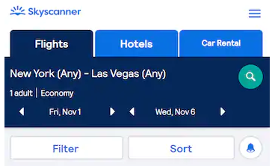
Thirdly, for pauses or parenthetical remarks, we use a closed em dash (no spaces—before or after). E.g. We love data, details, and patterns—and we explain them in a human way.
NOTE: You may see UK source content use a hyphen where an en dash or em dash should be used, please correct this in the target. If the punctuation separates two tags, be sure to check the context in Memsource to help you determine which case you’re dealing with.

Slashes
Please use no spaces before or after a slash (also known as “oblique”) when used between individual words, letters, or symbols, and use one space before and after the slash when used between longer groups which contain internal spacing:
outbound/inbound
Name of Operator / Legal Representative

Spaces
Please use a non-breaking space between the unit of measure and the number as well as between words that should not be split between two lines:

Price Alert (and other product names)
100 mi

Exceptions: Please do not use spaces between numbers and a percentage symbol, temperature in degrees and the duration of flights indicated in hours and minutes, e.g.

5%
90°F
5h 34m

Emphasis and intensifiers
Sometimes we use formatting and wording to emphasize key information for it to be easy to spot, or as an intensifier for a part of the message.
As a rule of thumb, prefer simple formatting (bold or italics) for emphasis and avoid using ALL CAPS or too many exclamation marks, as they can feel like shouting or spammy marketing.
Do | Don’t
Secure the car you really want 🚘 | Secure the car you REALLY want 🚘
 | Secure the car you really want!!!!! 🚘🚘

References
When you refer to other content (pages, features, sections, links), use clear, consistent names and, where relevant, the exact label used in the UI. This is where you will often need to change single quotes (UK source) to double quotes for US English.
Do | Don’t
Click the "Back to results" button below, and we will take you back to your Skyscanner search to try again. | Click the ‘Return to results’ button below, and we will take you back to your Skyscanner search to try again.
 | Click the BACK TO RESULTS button below, and we will take you back to your Skyscanner search to try again.

Capitalization

Titles and CTAs
As a rule of thumb, we avoid title case and prefer sentence case for titles and CTAs, except for some Marketing and Ads content.
Use a capital letter for the first word and for any proper nouns and keep the rest in lower case.
Do | Don’t
Book now | Book Now
Plan your next trip with Skyscanner | Plan Your Next Trip With Skyscanner

Months and days
Dates should be localized from the British format (DD/MM/YYYY) to the American format (MM/DD/YY). Please use cardinal numbers (Jan 1) rather than ordinal numbers (Jan 1st), regardless of whether the year is indicated or not.
Do | Don’t
03/25/2025 | 25/03/2025
Fri, Nov 1 | Fri, Nov 1st

Capital letter after colon
In US English, a capital letter is used following a colon if it introduces a complete sentence, a quotation, or a proper noun.

Glossary terms / product names
Glossary terms and product feature names should follow a consistent capitalization pattern across the product. Use sentence case for descriptive unless they are treated as branded names in your language.
Keep capitalization the same in UI and running copy, and do not switch between different styles (for example, avoid mixing “Price Alerts” and “price alerts” without a clear rule). E.g.
Learn more about Drops
Explore everywhere in May.
Find trips that fit your budget with Explore Everywhere.
Set your Price Alert for this flight.

Abbreviations and acronyms
Use abbreviations and acronyms only when they are widely understood by travelers in the US market (for example: airport codes, well-known transportation terms). If there is a risk of confusion, write the full term on first mention and add the abbreviation in brackets. Avoid creating new abbreviations just to save space.
Do | Don’t
“Value Added Tax (VAT)” on first mention, then “VAT” later. | Use internal or unclear acronyms without explanation, such as “Check your PNR” as travelers in the US may not recognize the term.

Addressing our users – Formality

How we address users must follow the norms and expectations of each language and market. In general, we aim for a friendly, respectful tone that feels like a helpful travel pal, not overly formal or distant.

CTAs and active voice
Use the active voice wherever possible, especially in headlines and CTAs. The active voice is usually clearer, and it sounds more like a direct conversation with our users.

- CTAs should be short, direct, and written in the active voice.
- CTAs should use the imperative verb tense
- Focus on what the user can do next, using clear verbs and simple structures.
- Avoid long or vague phrases and avoid passive constructions where the user is not the clear subject.
- When adapting to each language, keep CTAs natural and action-oriented, in line with local expectations for apps and websites.

Do | Don’t
Book now | Ready to start booking?
Discover our map | Discovering our map
Show flight deals | Display a selection of available flight options

Linguistic sequence

Geo-terms
Use the official or most widely used local names for countries, cities, regions, and airports, and keep them consistent across all content. Avoid outdated, politically sensitive, or rarely used forms, and don’t over-translate when travelers expect the original name (for example, in airport names or well-known landmarks).

Airport names
When translating airport names, refer to the official sources to make sure the name is correct.
Never add the word “airport” when translating an airport name to avoid duplication; it’s usually used to populate placeholders in a running copy, and the term “airport” is added to the copy when needed.
Example:
Fly from @@airport-name@@ Airport
Do | Don’t
Paris Charles de Gaulle | Paris Charles de Gaulle Airport

Cultural sensitivity

Emojis and symbols
- Use emojis and symbols sparingly and only where they support clarity or add a light, on-brand touch.
- Make sure they are universally understood and appropriate in your market.
- Avoid replacing key words with emojis, and never use emojis in legal, policy or serious problem/incident messages.

When possible, replace any emojis or symbols present in the source copy if they are culturally inappropriate or the meaning is unclear in your market. When not possible/editable, flag the inappropriate content to Skyscanner and suggest a more suitable equivalent.

Imagery
Imagery and references you encounter on the Skyscanner product and other materials that are acceptable for the UK source market are generally acceptable for the US market as well. However, please flag any imagery or references that could be seen as culturally inappropriate in the US (clothing, appearances, gestures, landmarks, food, family roles, etc.).

Translation guidelines per content type

User Interface (UI)

- Be short, clear, and action-focused. Prioritize clarity over playfulness.
- One idea per string; avoid ambiguity and extra words.
- Use the same wording consistently across product (e.g. always “Price Alerts,” not sometimes “Price Watch”).
Do | Don’t
Show flights / View deals | Let’s take a look at some awesome flights just for you!
Trip saved | We have successfully completed the saving of your trip
Something went wrong. Try again. | Oops, that didn’t work for some mysterious reason…

Marketing
There is more room for creativity for Marketing content—we want the copy to sound natural, fluid, and inspirational. Avoid sticking too close to the source text and make sure the translation feels like it has been created in American English originally.
- Use the playful, geeky, helpful Skyscanner voice, but keep promises realistic and compliant
- Focus on traveler benefits: saving time, money, effort, or discovering new places.

Do | Don’t
Explore New York for less—compare flight deals in seconds. | Book the best flights to New York now.
Plan your next city break with flights, stays, and car rental in one place. | Select origin, destination, and dates to start your search
Get ideas for your next beach escape, from nearby coasts to faraway islands. | Prepare to have your mind blown by the most epic beaches on Earth!

SEO
- Prioritize natural language, not keyword stuffing
- Write the way travelers actually search and think, while keeping our tone.
- Use clear, descriptive headings and titles
- Keep meta titles and descriptions concise and helpful

Do | Don’t
Compare cheap flights to Barcelona and find dates that fit your trip. | Compare cheap flights to Barcelona and find cheap dates that fit your trip.
Weekend trips from London: Find short flights and great city breaks. | Urban leisure experiences for time-poor consumers departing from London.
Search and compare flights to Tokyo, filter by airline, time, and stops, and track prices. | The ultimate place to find unbelievable flight deals to Tokyo.

Google Ads
- Be very concise; use clear benefits and a direct call to action. There are usually strict character limits.
- Avoid clickbait and unprovable claims (no “#1,” “best,” “cheapest ever”).
- Avoid exclamation marks and other unnecessary punctuation.
- Use common search language that travelers would type.

Do | Don’t
Compare flights to Tokyo and save time. | Get the absolute best flights to Tokyo here!
Find great flight deals to Rome | Cheapest flights anywhere, guaranteed!

App store
- Highlight main benefits and features clearly (search, compare, track prices).
- Use simple, natural phrases that work well in screenshots and previews.
- Avoid superlatives and guarantees.

Do | Don’t
Compare flights, hotels, and car rental in one place. | The only travel app you’ll ever need.
Set price alerts and get notified when fares drop. | Find the best flights in the world, every time.

Editorial and blog posts
- Use a warmer, more descriptive tone, but keep it factual and practical.
- Balance inspiration with concrete tips (times to go, rough prices, how to get around).
- Adapt and localize content that isn’t relevant for your market
- Please flag any content that isn’t relevant for the US market via the query/bug submission form. E.g. Marketing content targeting end-of-month salary pay days, as the US often uses a 2-week pay schedule. Though this sort of content may not work in the US, it may still be needed for users in other locales that have US English selected as their language.
Do | Don’t
If you’re on a budget, look for flights midweek and avoid federal holidays. | Only fools fly in summer—you must go in spring or not at all.

Emails and push notifications
- Keep subject lines short and clear, and body copy friendly, helpful, and inspirational.
- Make it obvious what the traveler can do next (search, check a deal, manage a booking).
Do | Don’t
Your price alert for Lisbon has changed | You won’t believe this crazy deal!!!
Prices for your London–Lisbon trip are lower. Check the latest fares and see if it’s time to book. | Click now or miss out forever—these are the best flights you’ll ever see.

Legal, policies, and terms and conditions

- Prioritize accuracy, clarity, and consistency over tone.
- Be precise and neutral; avoid jokes, idioms, and emotional language.
- Do not add promises or interpretations that are not in the source text

Do | Don’t
These terms apply to all searches and bookings made on our platform. | These terms usually apply to most searches and bookings.
We do not guarantee the availability or price of any flight until your booking is confirmed. | We can’t always guarantee availability or price before your booking is confirmed.

Other Skyscanner-specific guidelines

Use of Skyscanner brand
The name Skyscanner is a core part of our brand identity and must be treated consistently across all languages. It should remain recognizable, correctly spelled, and used in a way that feels natural to the American audience while still protecting the brand.

Feature naming
When localizing feature names, focus on meaning and user clarity, not on literal translation. A good feature name should be:
- Short and easy to scan
- Clear about what the feature does
- Natural and familiar in US English
- Consistent with terminology used by other travel providers in the US
Before finalizing a name, check:
- How similar features are named by local travel providers
- Whether the term is already standard or commonly understood by travelers
- Whether the name could be misinterpreted
Example:
The term “Packages” may be misunderstood as “parcels” in some languages, while we refer to a new vertical offering vacation packages including flights and a hotel.
A clearer, more natural option in your language could be “vacation packages” or the local equivalent travelers recognize.

The use of “Best”

Be careful with the use of “best” and superlatives in general. We are unable to claim that we can find travelers the “best prices” and “best deals” as this is an objective claim versus our competition that we would not be able to substantiate.

We can, however, use “Best” when there is a clear disclaimer explaining how "best" is measured.

Example:
Do | Don’t
This is the best price we found on our platform, according to our extensive search. | This is the best price for the flight.

Do | Don’t
Compare flight deals to Paris and find the right option for you. | Find the best flights to Paris.

For example, we can sort our flight results by “Best” results since we have a disclaimer clearly explaining how this is measured:

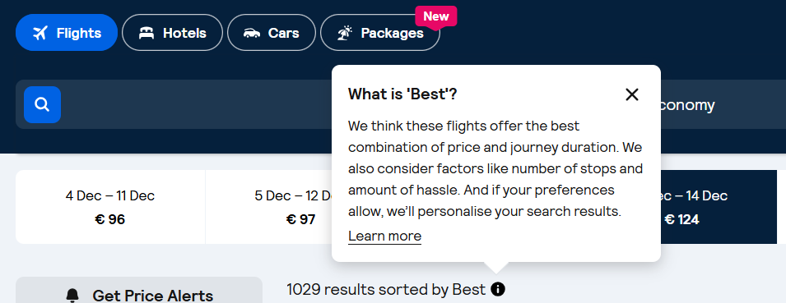

Generally, when the UK English copy says “best,” it’s safe to translate it the same way. When this is not the case, do not use “best” or other superlatives. Instead, use subjective claims such as “epic prices” or “amazing deals.”

The use of “Discount”

Skyscanner never offers discounts to users. Any discounts come from partners (for example Trip.com), not from Skyscanner.
For this and especially for legal reasons, we can therefore never imply that “we offer” or “Skyscanner offers” a discount. This must be translated in a neutral way, i.e. “You are offered a discount.”

Translating sustainability-related content
When localizing content about anything related to sustainability for Skyscanner, it’s essential to communicate responsibly and avoid greenwashing. Travel has an undeniable environmental impact, and our language must reflect this honestly and transparently. Use the following principles when translating or adapting sustainability-related content:
- Prefer comparatives over absolutes. Use relative statements such as “X is more sustainable than Y,” rather than implying that any option is fully sustainable.
- Avoid superlatives. Do not use expressions like “the most ecological flight” or “the greenest option,” as they can overstate environmental benefits.
- Use transparent and factual language. Base all claims on clear, measurable data.
- Steer clear of vague or unregulated terms. Avoid words like “natural,” “green,” “non-toxic,” and “environmentally friendly,” unless the statement is supported by verifiable, standardized criteria.
- Do not make unsubstantiated claims. Only reference environmental performance when data is available. Never imply that a flight or travel option is “sustainable,” “eco,” “green,” “clean,” “planet-friendly,” or “guilt-free.”
- Avoid reinforcing “green” imagery or symbolism. Be cautious with metaphors and word associations that might imply aviation is environmentally harmless. Overuse of green or nature-themed language can unintentionally suggest a level of sustainability that does not exist in commercial aviation today.
Do | Don’t
This flight emits 20% less carbon than a typical flight on this route | This flight is 20% more ecological/low-emission/environmentally friendly than a typical flight on this route
 | This is a sustainable flight
 | This is the most sustainable flight
 | This is a greener choice

Accessibility guidelines

See the localized Accessibility guidelines here.

Useful resources and links

For guidelines regarding spelling, please refer to the Merriam-Webster dictionary.

Some common spelling differences are outlined in the table below:

British English | American English
-ou (e.g. colour, behaviour, mould) | -o (e.g. color, behavior, mold)
-re (e.g. metre, fibre, centre) | -er (e.g. meter, fiber, center)
-ise (e.g. appetiser, familiarise, organise) | -ize (e.g. appetizer, familiarize, organize)
-ence (e.g. defence, offence, licence) | -ense (defense, offense, license)
-ell- (e.g. cancelled, jeweller, marvellous) | -el- (e.g. canceled, jeweler, marvelous)
-l- (e.g. enrol, fulfil, skilful) | -ll- (e.g. enroll, fulfill, skillfull)
-t (e.g. burnt, dreamt, leapt) | -ed (e.g. burned, dreamed, leaped)
-y- (e.g. tyre) | -i- (e.g. tire)
-oe-/-ae- (e.g. anaemia, diarrhoea, encyclopaedia) | -e- (e.g. anemia, diarrhea, encyclopedia)
-ogue (e.g. analogue, monologue, catalogue) | -og (e.g. analog, catalog)  *Note that –ogue is the preferred form in American English for certain words (monologue)

The following words are spelled differently in British English depending on whether they are nouns or verbs, whereas American English uses only the British verb form as the spelling for both senses.
